**Recruitment mail**

Hello everyone,  
  
We are conducting a study collaboration in virtual environment and are recruiting volunteers to participate.

The experiment will allow you to discover and use virtual reality technology.

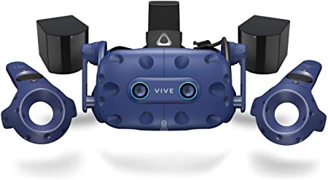

HTC Vive pro and controllers

The study should require 2 sessions of 45 minutes each and will consist of manipulating virtual images using the HTC Vive pro VR-HMD.

We recruit couples, or pairs of people that are already in close contact (such as housemates sharing a house, close friends meeting regularly, office mates working closely together, etc.). Both participants should be 18 years old or older.

To participate, please send us a mail at: [camille.dupre@u-psaclay.fr](mailto:camille.dupre@u-psaclay.fr), and we will contact you for more information.  
  
Thank you,